Seitei Jōdō

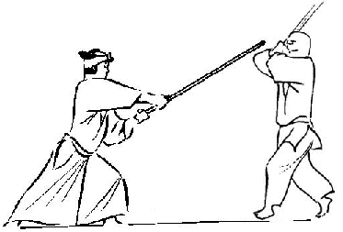Seitei Jōdō is practiced by the All Japan Kendo Federation (全日本剣道連盟 Zen Nippon Kendō Renmei). Seitei Jōdō starts with 12 pre-arranged forms (kata), which are drawn from Shintō Musō-ryū. In addition to these 12 kata, the student will also study their koryū. Jōjutsu has also been adapted for use in the Japanese police force, who refer to the art as keijō-jutsu (警杖術), or police stick art.

Seitei Jodo contains twelve forms (kata) developed in part by Shimizu Takaji and by a committee tasked with the creation of a compact Jōdō system to be taught mainly in Kendo dojos. The result was the Zen Ken Renmei Seitei Jōdō system containing twelve forms (kata) and twelve basic techniques (kihon).

Both the basic techniques and forms are drawn primarily from the koryu martial art Shinto Muso-ryu. The kata were chosen from the three first series of SMR, Omote, chudan and Ran ai as they were seen to best represent the art. Ten of these kata were taken from the existing SMR kata but with minor modifications as to better suit the requirements of the Kendo Federation. The two other kata were created specifically for the new Seitei Jōdō system and were not part of the original SMR-system. Seitei Jodo is today taught as a part of the Zen Nihon Kendo Renmei syllabus (All Japan Kendo Federation).

|  |  |
| --- | --- |
| **Kihon** | **Kata** |
| 1 Honte Uchi 2 Gyakute Uchi 3 Hiki Otoshi Uchi 4 Kaeshi Zuki 5 Gyakute Zuki 6 Maki Otoshi 7 Kuri Tsuke 8 Kuri Hanashi 9 Tai Atari 10 Tsuki Hazushi Uchi 11 Dobarai Uchi  12 Tai Hazushi Uchi (left and right) | 1 Tsuki Zue 2 Suigetsu 3 Hissage 4 Shamen 5 Sakan  6 Monomi 7 Kasumi 8 Tachi Otoshi  9 Rai Uchi 10 Seigan  11 Midare Dome 12 Ran Ai |